TG4 - Sceideal an Fhómhair/Autumn Launch 2019

Eolas faoi na Cláir/Programme information

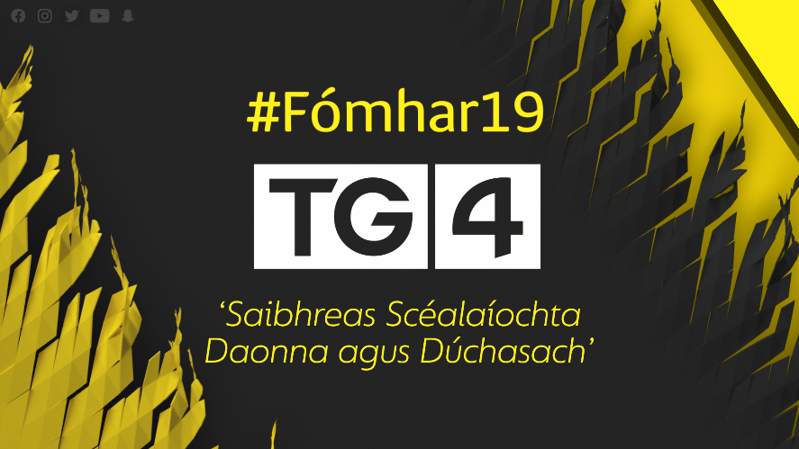

Faisnéis / Documentaries

Finné

Á spreagadh ag cláir faisnéise de chuid Netflix le blianta beaga anuas, tá Finné ar ais ar TG4 don dara sraith. Á léiriú ag Tua Films agus á chur i láthair ag comhfhreagraí RTÉ, Orla O'Donnell, nochtfaidh Finné tuilleadh scéalta cumhachtacha - scéalta faoi fhulaingt, éagóir, fuascailt agus teacht aniar. Inseoidh daoine a bhí i gcroílár chuid de na cásanna ba mhó sa tír a scéal ar a mbealach ionraic féin chun léargas pearsanta agus ar leith a thabhairt don lucht féachana ar an méid a bhain dóibh.

Documentary series 'Finné', inspired by Netflix documentaries of recent years, is back for a second series on TG4. Produced by Tua Films and presented by RTÉ correspondent Orla O' Donnell, 'Finné' will visit more powerful Irish stories, stories about suffering, injustice, redemption, resilience and strength. The witnesses' honest telling of their stories will ensure that they be brought to light once more and their stories will be told in the same personal style; through their own eyes to give the viewer a unique view of their incredible experiences.
Arna léiriú ag / Produced by Tua Films

Uchtú – Evanne Ní Chuilinn
NUA - Clár faisnéise 70 nóiméad ina bhfiosróidh an craoltóir Evanne Ní Chuilinn, a huchtaíodh ina páiste agus ar máthair í féin anois, scéal fada, anróiteach an uchtaithe in Éirinn. Casfaidh sí le lucht dlí, le gníomhaithe agus le daoine ar an dá thaobh den phróiseas uchtaithe - na leanaí agus na tuismitheoirí.
New -In this 70-minute authored documentary, broadcaster, mother and adopted child Evanne Ní Chuilinn will explore the long and often difficult story of adoption in Ireland. She will meet with law-makers, activists and people who have gone through the adoption process as children and parents. This programme will provide the human story behind each and every aspect of adoption.
Arna léiriú ag / Produced by Tyrone Productions

Saol an Mhadra Bháin
NUA - Sraith faisnéise dhá chuid, dhátheangach í Saol an Mhadra Bháin a thabharfaidh léargas ar leith ar an leas a bhaintear as madraí oibre in Éirinn agus mar atá na gadhair seo ag spreagadh eolaithe agus saineolaithe leighis chun teacht ar réiteach ar fhadhbanna sláinte ar fud na cruinne. Insítear scéal na bhfear, ban agus páistí in Éirinn a bhfuil a gcaighdeán saoil feabhsaithe ag na madraí ar leith seo.
New -This landmark, two-part bilingual documentary series explores Saol an Mhadra Bháin / The Secret World of Working Dogs and shows how their extraordinary abilities are helping doctors and scientists to find breakthrough medical solutions to worldwide health problems. It also tells the stories of Irish men, women and children who have had their quality of life dramatically changed and improved by their newly established partnership with their Working Dog.
Arna léiriú ag / Produced by Midas Productions

Tabú
Sraith faisnéise ionraic a thabharfaidh léargas fíorspéisiúil ar Éirinn sa lá atá inniu ann. Faoi thrácht sa dara sraith beidh daoine, áiteanna agus ábhar a thabharfaidh léargas spéisiúil ar shochaí na tíre mar atá sa lá atá inniu ann, ábhair nach ndéantar mórán cainte fúthu. I measc na n-ábhar beidh easpa dídine, páistí a bhfuil fadhbanna sláinte ainsealacha acu, ailléirgí, soláthar díreach, pobal trasinscneach na hÉireann, oibrithe leighis ar an líne tosaigh ar fud na cruinne, dúshlán na n-iascairí, an Garda Cósta agus deireadh le portaigh Bhord na Móna.

Tabú is a series of hard-hitting factual documentaries that offer a startling, compelling and uncompromising look at lesser spoken of topics in Ireland today. Subjects such as Homelessness, Children with chronic Health conditions, Allergies, Direct Provision, Being Transgender in Ireland, Worldwide frontline emergency medical workers, Ireland's Offshore Fishing industry, The Coast Guard and the imminent closure of the Bord na Móna bogs are discussed as 1 hour stand alone documentaries that provide insightful yet engaging viewing.
Arna léiriú Midas Productions / Produced by Midas Productions

Toraigh – Creag Bheag i Lár na Farraige
Nua - Ní farraige amháin a scarann oileáin ón mórthír. Is áit ann féin é Toraigh, oileán atá ar cheann de na hoileáin is scoite in Éirinn agus a bhfuil cónaí ar phobal Gaeltachta de chúpla céad duine ann. Mothaíonn lucht an oileáin go bhfuil siad scoite agus stoite agus i bhfad ar shiúl ó na daoine a dhéanann na cinntí i mBaile Átha Cliath. Cén dóigh ar féidir leis an phobal seo, atá ar imeall na hÉireann agus na hEorpa, saol ar leith sin acu féin a chaomhnú?
New -It's more than just the sea that can separate island life from the mainland. Tory Island is a unique location, a few hundred strong Irish speaking community on Ireland's most remote inhabited island. This island community feels isolated and vulnerable, and very distant from the decision makers in Dublin. How can this community, on the very margins of Ireland and Europe, preserve its unique way of life?
Arna Léiriú ag / Produced by Dearcán Media

Fear Darb Ainm Harris
Nua - Clár faoin aisteoir mór le rá Richard Harris as Luimneach. Má bhí cáil ar Harris de bharr a chuid aisteoireachta i scannáin mhóra Hollywood bhí cáil freisin air de bharr a chuid óil agus ragairne. Fear é a bhí an-bhródúil as a thír dhúchais agus ba mhinic a labhair sé faoi Éirinn agus Luimneach. Déanfar cur síos sa chlár faisnéise seo ar shaol Harris - sna scannáin agus ar stáitse agus ar a shaol pearsanta. I measc na bpearsana mór le rá a bheidh páirteach sa chlár beidh Clint Eastwood, Daniel Radcliffe, Ridley Scott, Jim Sheridan agus Stephen Rea.
New -Richard Harris was celebrated as much for his colourful life off screen, as for his many memorable roles on screen. He was the last of the great hell-raisers; a dinosaur from an era when movie stars misbehaved and the public loved him for it. He wore his Irish heritage as a badge of pride and talked of Ireland and Limerick at every opportunity. Featuring exclusive interviews with some of Hollywood's elite, including Clint Eastwood, Daniel Radcliffe, Ridley Scott, Jim Sheridan and Stephen Rea, this documentary explores Harris' fascinating life both on and off screen.
Arna Léiriú ag / Produced by Dearg Films

Máthair Trump – The President’s Mother
Nua - Idir phictiúir chartlainne agus chomhfhreagras chomh maith le hagallaimh le daoine as sráidbhaile a hóige in Albain, tabharfar léargas sa chlár faisnéise seo ar aistear Mary MacLeod, máthair Uachtarán Mheiriceá, as Leódhais in Inse Ghall go dtí an saol rachmasach a chaith sí pósta isteach i gceann de na teaghlaigh is saibhre i Nua-Eabhrac.
Cé go raibh aithne mhór ar mhuintir Donald Trump ar thaobh a athar is beag atá ar eolas faoi thaobh a mháthar. Ar Leódhais, oileán in Inse Ghall, a tógadh Mary MacLeod agus bhí sí ar dhuine de na mílte a chuaigh ar imirce go Meiriceá sa tóir ar shaol níos fearr. Is beag tagairt a dhéanann Uachtarán Mheiriceá ar an gceangal atá aige le hAlbain. Rachaidh Síle Nic Chonaonaigh go hInse Ghall chun Máthair Trump a fhiosrú.
New - While we all know about Donald Trump and his father’s background little is known about his late Mother’s background. Mary Macleod was raises in the remote Isle of Lewis in the Hebrides and was one of thousands of immigrants who left the Island for America in search of a better life.
While Donald Trump made few mentions of his late mother while he was property and media mogul as President he does often reference his Scottish roots.Síle Nic Chon Aonaigh goes on a journey and explores the story behind Mary MacLeod - how she was part of the great wave of American immigration and how she became Mother to the President of the United States.
From the Isle of Lewis to New York and to Washington we follow her fascinating story.
Arna léiriú ag / Produced by Mast Ard Productions

An Bhoirinn – Áit Aislinge
NUA - Sraith ceithre chlár faoin mBoirinn. Turas álainn físiúil feadh na séasúr ar an áit ar leith seo i dteannta daoine a bhfuil cosaint agus caomhnú déanta acu ar a n-oidhreacht le 6,000 bliain. Aithnítear an Bhoirinn ar fud an domhain mar áit álainn, ar leith, tírdhreach beo nach bhfuil a leithéid eile ann ar fud na cruinne. Fiosrófar sa tsraith an saol agus na daoine agus mar a thagann athrú agus iontas le gach séasúr. Idir gheolaíocht, sheandálaíocht, thalmhaíocht, stair, oidhreacht, an chruthaitheacht agus an pobal - is áit ann féin an Bhoirinn a bhfuil áilleacht agus spiorad ar leith ag baint leis. Tá an cultúr agus an pobal chomh bríomhar leis an tírdhreach féin.

NEW - This is a four-part series on the Burren. A visually stunning journey through the seasons in this extraordinary place in the company of the people who have protected and cherished their heritage for over 6,000 years and ensured that its uniqueness survives and thrives. Recognised throughout the world for its austere beauty, the Burren is a living landscape like no other and this series will be a creative exploration of the life of this singular place, its people and how each season brings new surprises that delight and amaze all who encounter them. The character of the Burren has evolved through a stunning combination of geology, ecology, archaeology, agriculture, history, heritage, creativity and community. These diverse influences infuse the area with a haunting, spectacular and world-unique beauty and spirit. Its culture and community are as vibrant as its landscape. Featuring a powerful and poetic script and a specially commissioned score, the series will be narrated to bring to life the nature, spirit and people of the dreaming Burren.
Arna léiriú ag / Produced by Phoenix Films

Martin McGuinness – I Fought, I made Peace, I made Politics
Nua - Clár faisnéise a thabharfaidh léargas ar leith ar shaol agus ar shaothar Martin McGuinness - pearsa mór i stair na hÉireann leis an mBreatain agus pearsa aitheanta go hidirnáisiúnta chomh fada is a bhain sé le réiteach aighnis, fear a chuaigh ó bheith san IRA go dtí ina fhear déanta síochána.
New - The film assesses the life and legacy of Martin McGuinness, a major historical figure in the relationship between Ireland and Britain and a global figure on the international landscape of conflict resolution as he journeyed from IRA man to Peacemaker.
Arna léiriú ag Ligid Teo / Produced by Ligid Teo.

CUMAR
NUA - Clár ar leith ina bhfiosraítear Gaillimh mar ionad ealaíne agus na tionchair éagsúla ealaíne a bhí ar an gcathair agus mar a tháinig siad le chéile. Caitheadh bliain ag taifeadadh na sraithe seo agus tugtar léiriú inti ar an athrú a thagann ar an gcathair leis na séasúir. I measc na n-ealaíontóirí a bheidh rannpháirteach, beidh an scríbhneoir Mike McCormack, an file Rita Ann Higgins, an t-amhránaí Róisín Seoighe, stiúrthóir an ghrúpa MACNAS, Noeline Kavanagh, an t-ealaíontóir as Conamara, Pádraic Reaney, an ceoltóir Máirtín O'Connor agus an fear seoigh Tommy Tiernan.
New: Cumar (the Irish for Confluence) is an artistic exploration of Galway examining the myriad confluences which have shaped its unique cultural fabric. Filming was carried out over four seasons charting the city and county's changing pallettes, moods and weather fronts! Featured artists include writer Mike McCormack, poet Rita Ann Higgins, Singer Róisín Seoighe, Macnas director Noeline Kavanagh, visual artist Padraic Reaney, musician Máirtín O'Connor and comedian Tommy Tiernan.
Arna léiriú ag / Produced by Magamedia teo

Fíorscéal
Sraith a thugann aghaidh ar mhórcheisteanna idirnáisiúnta trí shúile na léiritheoirí teilifíse is misniúla agus is conspóidí ar domhan le rogha clár faisnéise ón iasacht le hathghuthú Gaeilge. Oscailt súl eile is ea gach clár.
A season of international documentaries that continue to throw (a sometimes disturbing) light on issues which affect us environmentally, socially, politically and globally.

Faisnéis Staire / History Documentaries
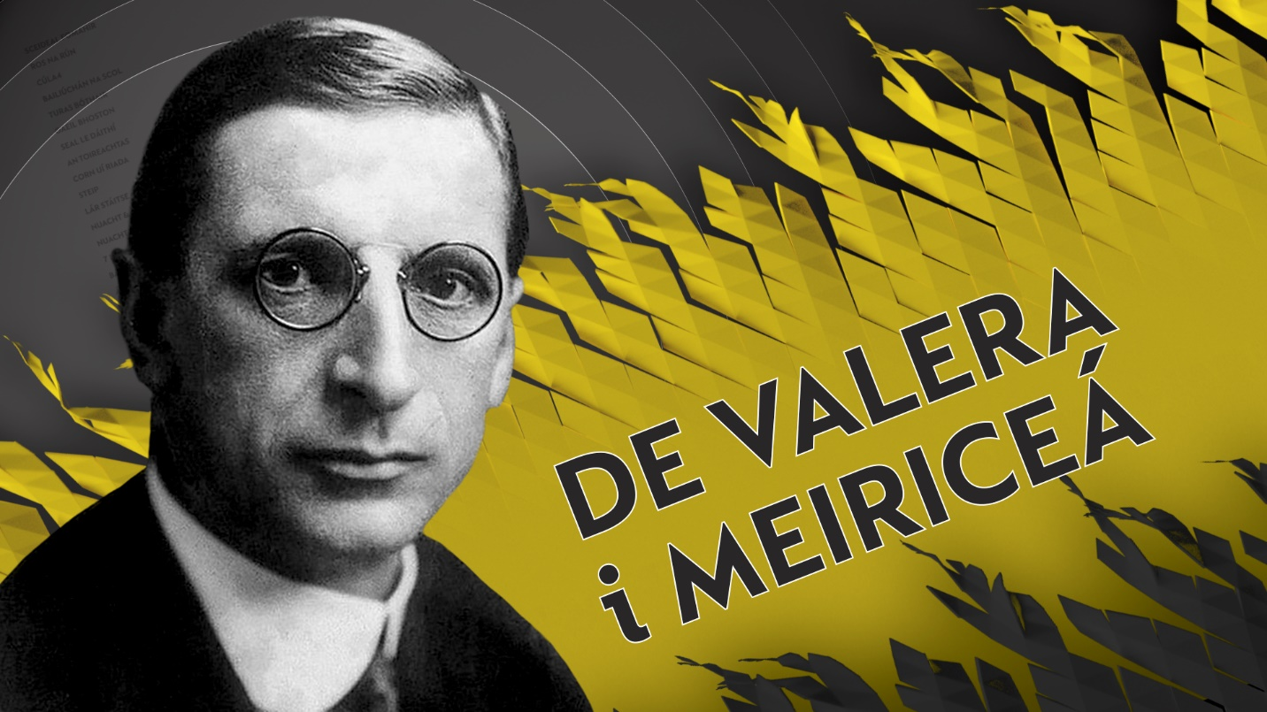
De Valera i Meiriceá
Nua - Sraith faisnéise dhá chlár ina ndéantar cur síos den chéad uair ar an turas achrannach a thug Éamon de Valera ar Mheiriceá i 1919. Tharraing an turas céanna achrann agus deighilt i measc Gael-Mheiriceánach cúpla mí sular tharla scoilt sa mbaile in Éirinn faoin gConradh Angla-Éireannach. Déanfar cur síos ar mar a d'éalaigh Éamon de Valera ar bhád go Meiriceá i 1919 agus gur fhógair sé i bhforhalla an óstáin ba rachmasaí ar domhan gurb é "An Chéad Uachtarán ar Éirinn" é. Ba í fírinne an scéil go rabhthas sa tóir ar de Valera agus go raibh Éire fós ina cuid d'Impireacht na Breataine. Ghlac na Gael-Mheiriceánaigh leis gan aon agó ach níorbh fhada go ndeachaigh cúrsaí in aimhréidh. Baisteadh tine ó thaobh na polaitíochta a bhí ann do de Valera a bhí nua ag an bpolaitíocht - ach sheas an méid a d'fhoghlaim sé dó agus d'imir tionchar mór air mar pholaiteoir ina dhiaidh sin - tionchar a d'imir seisean arís ar ais ar Éire a linne go ceann leathchéad bliain.

New - The extraordinary story of how Éamon de Valera stowed away on a ship to America in 1919 and announced himself in the lobby of the world's most expensive hotel as "The First President of Ireland". In truth, de Valera was a wanted man and Ireland was still part of the British Empire. Immediately Irish America makes him a star. Then it all goes incredibly wrong. Using previously unseen archive material preserved in New York, we tell on screen for the first time the untold story of the political baptism of fire for de Valera that follows and how the trip shapes him into the politician he would become - a man who would go on to shape modern Ireland for the next fifty years.
Arna Léiriú ag / Produced by Forefront Productions

The Irish Derby – Níos Mó ná Rása
NUA- Tá an Irish Derby ar cheann de na himeachtaí capall is mó sa bhféilire spóirt. Is clár faisnéise é ‘The Irish Derby – Níos Mó ná Rása’ faoi Dhearbaí na hÉireann, rás mór idirnáisiúnta capall a reáchtáiltear ar an gCurrach i gCill Dara agus an stair a bhaineann leis ó bunaíodh é in 1866 go dtí an lá atá inniu ann. Chomh maith le léargas a thabhairt ar imeachtaí móra a thit amach i stair na hÉireann, tabharfaidh an clár tuiscint don lucht féachana ar cheann de na traidisiúin spóirt is mó in Éirinn.

New - Set against the backdrop of relevant historical events in Ireland "The Irish Derby - Níos Mó Ná Rása" captures the essence of the Irish Derby from its humble beginnings in 1866 to becoming a top international race. The fascinating one-hour bilingual documentary also merges its colourful and inspirational past with its exciting future, through the new multi-million euro redevelopment. Renowned for its human and equine stars, characters and celebrities, this big day out at the historic Curragh racecourse is one of the most important dates on the social calendar.

Arna léiriú ag / Produced by Bankos Tales Productions

Cogadh Faoi Cheilt – Scéal an IRB

Nua - Déantar dearmad ar scéal an IRB sa ré thábhachtach seo de chomóradh. Gan an méid a rinne an IRB sna blianta roimhe, seans nach dtarlódh éirí amach ar bith i 1916, agus ní féidir críochdheighilt a thuiscint gan smaoineamh faoi ról an IRB ó 1918-24. Déanann Cogadh Faoi Cheilt achoimre ar aidhmeanna an IRB - poblacht aontaithe saolta a bhunú ina mbeadh deighilt shoiléir idir creideamh agus stát - i gcodarsnacht leis an gcríochdheighilt a tháinig chun cinn i ndiaidh 1920.

New - The story of the Irish Republican Brotherhood (IRB) has been hugely overlooked in this period of commemoration. Without the work of the IRB in the previous decades it is arguable whether 1916 would have happened at all, and it is impossible to understand partition without taking into consideration the role of the IRB in the 1918-24 period. Cogadh Faoi Cheilt outlines the possibility of what the IRB hoped to achieve - a secular unified republic with a clear division between religion and state - in contrast to the partitioned country that emerged post 1920.
Arna Léiriú ag /Produced by Dearcán Media

Máthair
Nua - Níl a dhath inchurtha le grá máthar. Ach ar smaoinigh muid riamh ar an tionchar a d'imir a máthair ar roinnt de na pearsana is mó i stair na hÉireann? Caithfear súil sa tsraith seo ar cheathrar ban, daoine tábhachtacha ina gceart féin, mná a thóg clann mhac a mbeadh tionchar ar leith acu ar stair na hÉireann - Speranza agus Oscar Wilde, Maud Gonne agus Seán MacBride, Kathleen agus Brendan Behan agus Alice agus Thomas McElwee.
New - There is nothing like a mother's love. But have we ever considered how their mothers shaped some of the most important personalities in Irish history? In this series we celebrate four important women who raised sons who shaped Irish history. The programmes examine the relationships between Speranza and Oscar Wilde, Maud Gonne and Seán MacBride, Kathleen and Brendan Behan and Alice and Thomas McElwee.
Arna Léiriú ag /Produced by Macha Media

Ceol Chogadh na Saoirse
Nua - Clár ina ndéantar seacht n-amhrán déag a bhaineann le Cogadh na Saoirse a thaifeadadh as an nua. Fiosrófar an gaol casta atá ag muintir na hÉireann leis na hamhráin sin agus an dóigh a bhfuil athrú tagtha orthu le 100 bliain.
New -With 17 new original recordings of songs associated with the Irish War of Independence and Civil War, from some of Ireland's greatest up and coming talent, "Ceol Chogadh na Saoirse" explores the complex relationship the Irish people have with these songs and how it changed over the last 100 years.
Arna léiriú ag / Produced by Imagine Media
Siamsaíocht / Entertainment
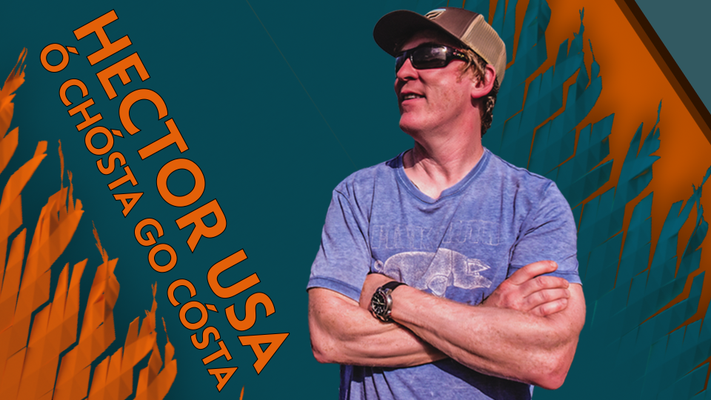
Hector USA – Cósta go Cósta

Tá Hector Ó hEochagáin, an fánaí is clúití agus is aitheanta in Éirinn, ar ais arís ar TG4. Ar Mheiriceá atá a thriail sa tsraith seo ina dtabharfaidh sé faoi aistear as Savannah, ar an gcósta theas, go San Diego. Seasfaidh sé in Alabama Georgia, i Mississippi agus i Louisiana agus as leis ansin go Texas, New Mexico agus Arizona sula gcríochnóidh sé i California. 8 stát agus breis is 5000 míle bealaigh, turas iontach agus aisteach a bheidh ann do Hector agus muide ina theannta.

Ireland's most famous intrepid traveller opens our eyes to "His America" as he takes on the road trip of a lifetime from Coast to Coast as he treks across the Southern States from Savannah on the Atlantic to San Diego on the Pacific. Hector USA will be road tripping from Georgia through Alabama, Mississippi and Louisiana into Texas, New Mexico and Arizona before finishing up on the Pacific seaboard in California. Covering 8 states and more than 5000 miles on the road, it will be one helluva of an awesome adventure with Hector taking us to a world only he can access.
Arna léiriú ag / Produced by Domhan Media

Underdogs

Tá Underdogs, sraith mhór-rachairte TG4, ar ais agus súil acu foireann nua glan a chur chun páirce. Grúpa fear cumasach, dílis agus aclaí a bheidh ag teastáil le haghaidh a thabhairt ar cheann de na foirne peile Gaelaí is fearr sa tír. Beidh foireann nua bainistíochta i gceannas na bhfear i mbliana; Mickey Ned O'Sullivan, iar-chaptaen agus iar-bhainisteoir ar Chiarraí, Valerie Mulcahy Chorcaí, duine de na peileadóirí mná ab fhearr riamh, agus Caoimhín Ó Casaide, laoch Ghaoth Dobhair agus iar-pheileadóir le Dún na nGall. Tabharfar bata agus bóthar d'fhear amháin as campa na Underdogs gach seachtain.

TG4's legendary GAA series 'Underdogs' is back and is putting a brand-new team of footballers together. A group of men who have enough skill, athleticism, and dedication to take on one of the best Gaelic football teams in the country. This year the management team will have a new line-up, including; former Kerry Captain and former Kerry Manager Mickey Ned O' Sullivan, Gaoth Dobhair legend and former Donegal Footballer Kevin Cassidy and former Cork Ladies Footballer Valerie Mulcahy will be back on the sidline.Each week Management will have to drop one or more of the players from the Underdogs.
Arna léiriú ag / Produced by Adare Media

CREATIVE COMPANY
NUA - Sraith nua glan é "Creative Company" a fhéachfaidh teacht ar an ionad oibre is cruthaithí in Éirinn. Cuirfear ealaíontóir isteach i ndeich gcomhlacht ar fud na tíre agus tabharfar de sprioc do na hoibrithe píosa ealaíne den chéad scoth a cheapadh in éineacht leis. Cibé an pictiúr nó dealbh, spreagfar oibrithe i ngach leibhéal den eagraíocht a bheith páirteach agus píosa ealaíne a dhéanamh ar láthair a gcuid oibre féin ón gcoincheap go dtí an toradh.
NEW - "Creative Company" is a brand new series that aims to find Ireland's most creative workplace. Placing an artist within a company, workers within ten different Irish organisations will be set the goal of making a fantastic piece of art together. Whether a painting or a sculpture, the workers from all levels in the organisation will be encouraged to operate as a team and make the piece of art on their own premises from concept to completion.
Arna léiriú ag / Produced by El Zorrero Films

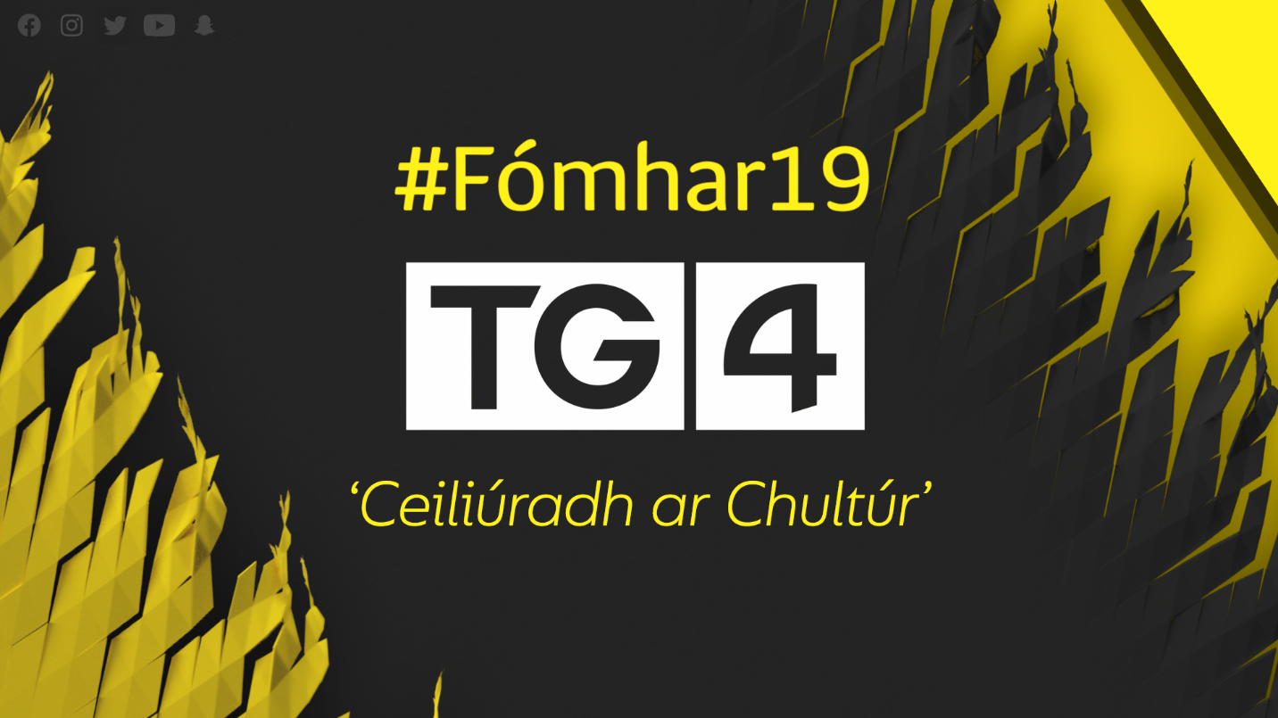

Ceiliúradh LGFA le LIDL

Clár siamsaíochta, arna léiriú le hurraíocht ó LIDL. Caithfear súil siar ar Chraobhchomórtas Pheil na mBan 2019 go dtí seo agus súil chun cinn ar na cluichí is mó i bhféilire Pheil na mBan - Cluichí Ceannais na hÉireann a bheidh ar siúl an lá dár gcionn.

A celebration of LGFA, proudly supported by LIDL, examining the Ladies Football Championship and the finals which takes place the following day.

The Irish Post Awards
Gradaim an Irish Post beo as Londain a thugann aitheantas do shaothar agus d'éachtaí na nGael i Sasana. Is í seo an 41ú bliain ag na Gradaim agus beidh grúpaí aitheanta ag seinm ar an oíche. Is iad Aoife Ní Thuairisg agus Eamonn Holmes a chuirfidh na gradaim i láthair.

Live from London, The 42nd annual Irish Post Awards takes place in prestigious Great Room at The Grosvenor House on Park Lane in London on the evening of 14th November. This event celebrates the contribution of the Irish Community to Britain and the Irish Diaspora around the world. There will be well over 1,200 distinguished guests attending from all walks of life to enjoy the ceremony and live musical performances. Our hosts for the evening will be Mr. Eamonn Holmes and Ms Aoife Ní Thuairisg.
Arna Léiriú ag / Produced by The Irish Post

Siamsaíocht Teaghlaigh / Family Entertainment
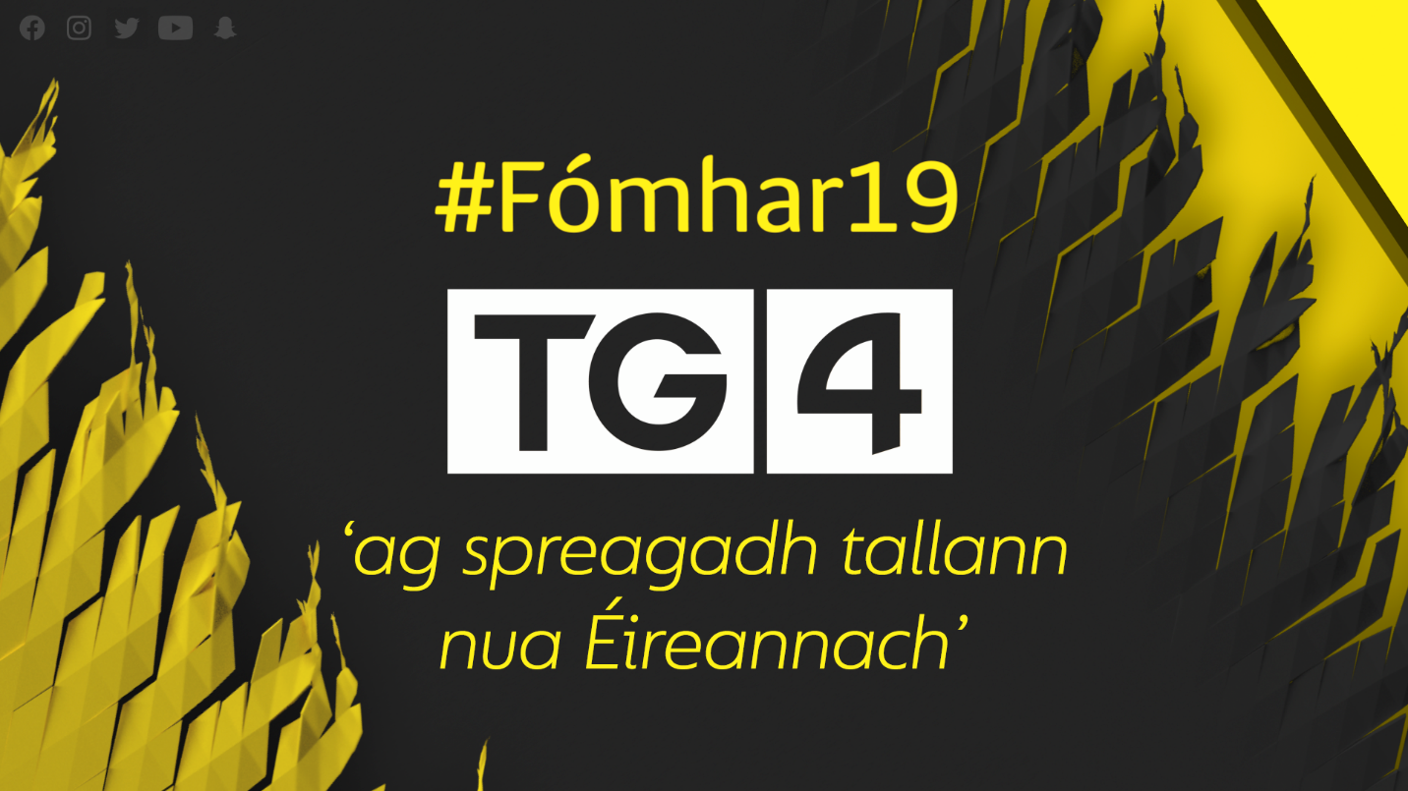
Go Gasta
NUA - Sa tsraith nua GO GASTA tabharfaidh dhá bhaile teorainneach agus a bhíonn de shíor ag coimhlint lena chéile dúshlán a chéile i gcomórtas nua bailte. Is í Máire Treasa Ní Dhubhghaill a bheidh i bhfeighil foireann amháin díobh agus Conal Ó Máirtín saoiste na foirne eile. Caithfidh foireann de sheisear ó bhaile amháin rith i dtreo an bhaile eile ach beidh constaicí go leor le sárú acu agus ar ndóigh beidh siad in aghaidh an chloig. An fhoireann is sciobtha a bhainfidh ceann scríbe amach na buaiteoirí. Beidh foirne againn as Dún na nGall, Gaillimh, An Rinn, Corcaigh, Ciarraí chun tabhairt faoin gcomórtas bailte GO GASTA!
NEW - In the new series GO GASTA, two local villages go head to head to settle old scores once and for all on a course littered with challenges and obstacles that goes from one village to the other . Each team sets out from their own village and race towards the opposing village and along the way they will have to negotiate different challenges against the clock. Fastest, fittest and strongest wins the day. And bragging rights to who is the GO GASTA champion, at least for one year anyway. The Series takes us all around the country from Galway to Donegal, Waterford, Cork and Kerry.
Arna Léiriú ag / Produced by Abú Media

Junior Eurovision
Táthar sa tóir arís ar amhrán agus ar amhránaí a sheasfaidh an fód d'Éirinn ag Comórtas Amhránaíochta Junior Eurovision 2019! Taylor Hynes as Baile Átha Cliath a chuaigh go Minsk sa Bhealarúis thar ceann na hÉireann anuraidh. Rachaidh plúr na n-amhránaithe óga ar stáitse arís i mbliana agus is iad na moltóirí - Gráinne Bleasdale, Chris Greene agus na haoi-mholtóirí Brendan Murray, Paul Harrington, Jedward, Charlie McGettigan, Linda Martin & Niamh Kavanagh - a thabharfaidh breithiúnas orthu. Cé a dhéanfaidh an beart agus a bheidh ag dul go dtí an Pholainn i mí na Samhna d'Éirinn?

The search for Ireland's entry for the 2019 Junior Eurovision is on! Last year Taylor Hynes from Dublin did the nation proud as he performed to a crowd of over 5,000 in Belarus, and sang live to millions of sitting rooms across the continent! The top young singers in Ireland will now take to the stage to perform for judges Gráinne Bleasdale, Chris Greene, and guest judges Brendan Murray, Paul Harrington, Jedward, Charlie McGettigan, Linda Martin & Niamh Kavanagh. Who will be flying to Poland in November to sing for Ireland? Junior Eurovision Éire, starting 9:05pm, Sunday, 1st of Sept. 2019.
Arna Léiriú ag / Produced by Adare Productions

Lurgan 2K19
Sraith siamsaíochta do dhaoine óga é Lurgan 2K19 ina dtaispeánfar físeáin nua ó, 'TG Lurgan' chomh maith leis na daltaí ardchumasacha a ghlacann páirt iontu. Tabharfar cuntas sa tsraith seo ar na heachtraí saoil a thug na daoine óga seo le chéile agus tabharfar léargas ar an tuiscint atá ag na scoláirí ar chultúr na Gaeilge tríd an gceol. Scéalta á n-insint le fís agus fuaim ag tarraingt ar na meáin shóisialta.
Lurgan 2K19 is a young people's entertainment series that features the music videos of online sensation 'TG Lurgan' while profiling the profoundly talented students who perform in them. The series chronicles the life events that have shaped a diverse and fascinating collection of young Irish people while capturing their contemporary creative expression of Irish culture through song. It's an upbeat, visual feast of social media inspired storytelling.
Arna Léiriú ag / Produced by Iris Productions

Cleas Act
Sraith úrnua siamsaíochta ar TG4 ina gcuirfear na páistí is barrúla, is caintí agus is cumasaí sa tír in bhur láthair gach Domhnach as seo go ceann 12 seachtain.
A new light entertainment show which puts the funniest, most talkative and capable kids on our screens for twelve weeks.
Arna léiriú ag / Produced by Tyrone Productions

Réalta & Gaolta
Leanfar leis an gcuardach don teaghlach is cumasaí sa tír! Sraith ceoil agus damhsa ina rachaidh teaghlaigh chumasacha san iomaíocht ar stáitse. Cé a bheidh ina seaimpíní in 2020?

The search for Ireland's most talented family is back! Singing siblings, dancing dynasties and rockin' relatives will battle it out on the stage to be crowned the champions for 2020.
Arna léiriú ag / Produced by Adare Productions

Scéalta Pobail / Stories connecting communities
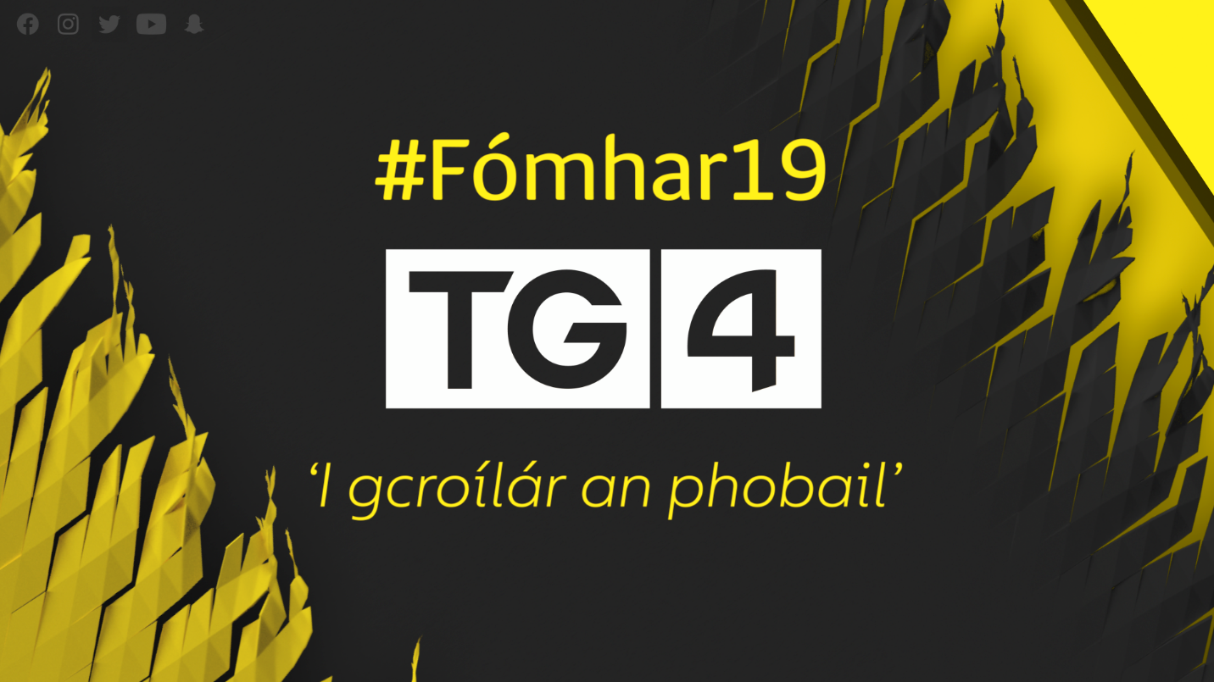
Turas Bóthair
Tá Turas Bóthair ar ais do shraith eile, an tríú sraith! Sraith ina bhfuil ceamaraí suiteáilte i gcarranna daoine ar fud na hÉireann le deis a thabhairt don lucht féachana dul ag cúléisteacht ar na paisinéirí agus eolas a chur ar na nithe atá ag déanamh tinnis dóibh. Idir scéalta lúcháire agus bróin, grinn agus tubaiste, grá agus briseadh croí, scéalta éadóchais agus dóchais - tabharfar léargas sa chlár ar an dearcadh atá ag an ngnáthphobal ar chúrsaí an tsaoil ón teicneolaíocht go tinneas, cearta na mban chomh maith le cuid mhór eile.

Turas Bóthair is back! This is the show that reveals what people really talk about in their cars. Once again we rig small cameras in dozens of cars across Ireland, allowing us to eavesdrop on real conversations as they happen. Expect moments of joy and sadness, comedy and tragedy, love and loss, friendship and romance, regret and reflection, despair and hope as drivers and passengers share their personal stories and views on love, relationships, sex, technology, transgender rights, fracking, conspiracy theories and much, much more.
Arna léiriú ag / Produced by Waddell Productions

Seoda Bhailiúchán na Scol
NUA - Is é 'Bailiúchán na Scol' an bailiúchán béaloidis is mó & is uaillmhianaí a rinneadh riamh in Éirinn. Bhailigh leanaí scoile as 5000 bunscoil beagnach leathmhilliún leathanach d'ábhar béaloidis óna muintir & óna gcomharsana idir 1937 & 1939. Sa tsraith seo, rachaidh seachtar ag tochailt i mBailiúchán na Scol lena fháil amach cad atá ann agus a mhéid den eolas, de na traidisiúin & nósanna a dtráchtar orthu - atá fós le sonrú i saol an lae inniu. Is iad Aenghus Mac Grianna, Sláine Ní Chathalláin, Diarmuid Lyng, Stiofán Seoige, Jó Ní Chéide & Máire Treasa Ní Cheallaigh an seachtar atá i gceist.
NEW - This new series looks at the Schools Folklore Collection to see if the beliefs of the past have any meaning in today's world. From 1937 to 1939, schoolchildren from 5000 schools across Ireland collected almost half a million pages of folklore from their relatives and neighbours, the most ambitious scheme of its kind ever undertaken. In this series, 7 presenters delve into the treasures of the collection to see if what they find has any relevance or resonance today. With Aenghus Mac Grianna, Sláine Ní Chathalláin, Diarmuid Lyng, Stiofán Seoige, Jo Ní Chéide & Máire Treasa Ní Cheallaigh.
Arna Léiriú ag / Produced by Aniar TV

Bailte
Sraith nua ocht gclár de Bailte ina dtabharfaidh Síle Nic Chonaonaigh cuairt ar bhailte fearainn ar fud na hÉireann chun an ceangal atá ag daoine leis an áit as a dtagann siad a fhiosrú. Fiosróidh sí an tírdhreach a mhúnlaíonn iad, an cultúr as ar fáisceadh iad agus na slite beatha a chothaíonn iad. I measc na mbailte a dtabharfaidh sí cuairt orthu sa tsraith nua seo beidh An Bun Beag i nGaoth Dobhair, Co. Dhún na nGall, An Gleann in Uíbh Ráthach, i ndeisceart Chiarraí agus cuirfear tús leis an tsraith ar an mBaile Uachtarach i gCorca Dhuibhne i gCo. Chiarraí.
Bailte returns with a new 8 part series examining life in townlands all over Ireland. Síle Nic Chonaonaigh discusses the connection people have with their homeplace, the influence the landscape has on life there, the culture that informs them and the changes in the ways people in rural Ireland are now making a living. Amongst the town lands visited in the second series Síle goes to An Bun Beag in Co. Donegal, An Gleann in South Kerry and we begin with An Baile Uachtarach on the Dingle Peninsula.
Arna léiriú ag / Produced by Aniar TV

Bádóirí
Ar imeall thiar na hEorpa, tá cultúr mara ar leith a bhaineann le Conamara agus an bád mór. Is í an bád mór a chothaigh agus a choinnigh beo na pobail ba bhoichte nuair ba mheasa an saol. Tá glúin óg bádóirí anois tagtha chun cinn a bhfuil a gcroí agus a n-anam fós sna báid agus a théann chun farraige gach bliain le súil is sraith geallta Chumann Húicéirí na Gaillimhe a thabhairt leo. Sraith geallta 2019 a bheidh faoi chaibidil sa dara sraith. Rachaidh muid chun farraige le criúnna na mbád ársa seo le léargas agus fháil ar an gcoimhlint a bhíonn idir ocht dteaghlach a bhfuil na báid seo sa mianach agus sa bhfuil acu.
The rocky inlets west of Galway Bay host the Galway Hooker boat racing series each year. Once the workhorses of the West coast, the distinctive rust-red calico sails of the Galway Hookers now race for glory throughout the Summer months where the family owned boats battle one another for the coveted prize of All-Ireland champions. In this 2nd series of ‘Bádóirí’, we again travel with the various crews for the duration of the 2018 season. The rivalry is local and intense, the competition fierce, and the waters treacherous.
Arna Léiriú ag / Produced by Aniar TV

Gaeil Bhoston
NUA - Le breis agus 150 bliain, tá glúin i ndiaidh glúine de Ghaeil ag tógáil ar obair a sinsear sa gcathair is Gaelaigh i Meiriceá, Boston. Inniu tá na Gaeil i lár na cumhachta i saol na polaitíochta agus duine díobh ina Mhéara ar an gcathair. Ach tráth is mó a bhfuil cumhacht agus údarás ag na Gaeil ann, tá deireadh ré ag teacht agus is gearr eile, is cosúil, a bheidh siad ar an ngrúpa imirceach is láidre sa gcathair. Á chur i láthair ag an iriseoir Seán Mac an tSíthigh a rachaidh go croílár an phobail seo, an pobal Gaelach is mó taobh amuigh d'oileán na hÉireann, le léargas a fháil ar an gcoimhlint síoraí a bhaineann le saol gach glúin imirceach.
NEW - For over 150 years, generations of Irish have been building upon their ancestors' work in America's most Irish city, Boston. Today, despite the Irish being to the fore of political life in the city, with an Irish man currently serving as Mayor, it seems an end of an era is looming as soon the Irish will no longer be the largest immigrant group in the city. Journalist Seán Mac an tSíthigh will venture to the heart of this community, the largest Irish community outside of Ireland, to get a rare glimpse into the constant conflict surrounding the lives of each generation of immigrants.
Arna léiriú ag / Produced by Aniar TV

Gaeltacht 2020
NUA - Sraith á cur i láthair ag Eibhlín Ní Chonghaile ina ndíreofar ar na nithe is mó atá ag déanamh tinnis do phobal na Gaeltachta sa lá atá inniu ann. Cúrsaí fostaíochta sa nGaeltacht a bheidh faoi chaibidil sa chéad chlár agus pléifear an fhostaíocht is fearr a fheileann i gceantair thuaithe. Féachfar sa dara clár ar na constaicí atá ag cur cosc ar mhuintir na Gaeltachta cur fúthu ina gceantar féin. An measa an fhadhb seo sa Ghaeltacht ná ceantair thuaithe eile? Is cinnte go dtabharfaidh na cláir seo ábhar machnaimh do phobal na Gaeltachta agus ar staid reatha na Gaeltachta agus a ndúshlán freisin. Leagfar béim ar an ról a cheart a bheith ag an bpobal féin in aon bheart a cheapfaí chun ceantair Ghaeltachta a thabhairt slán as an tsáinn eacnamaíochta, sóisialta agus cultúir ina bhfuil siad.
NEW - A series presented by Eibhlín Ní Chonghaile that focuses on issues faced by Gaeltacht communities today. The first programme will deal with the issue of employment or the lack thereof in the Gaeltacht. The second programme will look at the barriers that are prohibiting people from the Gaeltacht from living in their own communities. Is this problem worse in the Gaeltacht than in other rural areas? 'Gaeltacht 2020' will certainly give the Gaeltacht community food for thought regarding the current state of the Gaeltacht and the challenges faced. There will be an emphasis on the role the community itself should play in any measures taken to get Gaeltacht areas out the other end of the economical, social agus cultural predicaments they currently find themselves in.
Arna léiriú ag / Produced by Aniar TV

Ár gClub
Beidh muid ar an láthair i gcumainn éagsúla sa tsraith 6 chlár seo le léargas a thabhairt ar na pobail, na pearsana, na teaghlaigh agus ar na nithe a thiteann amach i gcumainn CLG feadh na bliana. CLG Naomh Anna Leitir Mór i nGaillimh, Rath an Iúir i Loch Garman agus Laochra Loch Lao i mBéal Feirste clubanna na bliana seo, meascán de chumainn tuaithe agus cathrach, sean agus óg, cumainn a léiríonn go paiteanta an bród, an mórtas agus an spiorad, an ceiliúradh agus an briseadh croí a bhíonn le brath i ngach cumann CLG.

A six-part fly on the wall series to gain insight into the communities, people, families and all that goes on in GAA clubs throughout the year. Clubs featured this year include CLG Naomh Anna in Leitir Móir, Galway, Ráth an Iúir in Wexford and Laochra Loch Lao in Belfast, a mix of urban and rural clubs, young and old, that clearly demonstrate the pride, spirit, celebration and heart-break that can be felt in every GAA club in the country.
Arna léiriú ag / Produced by Aniar TV

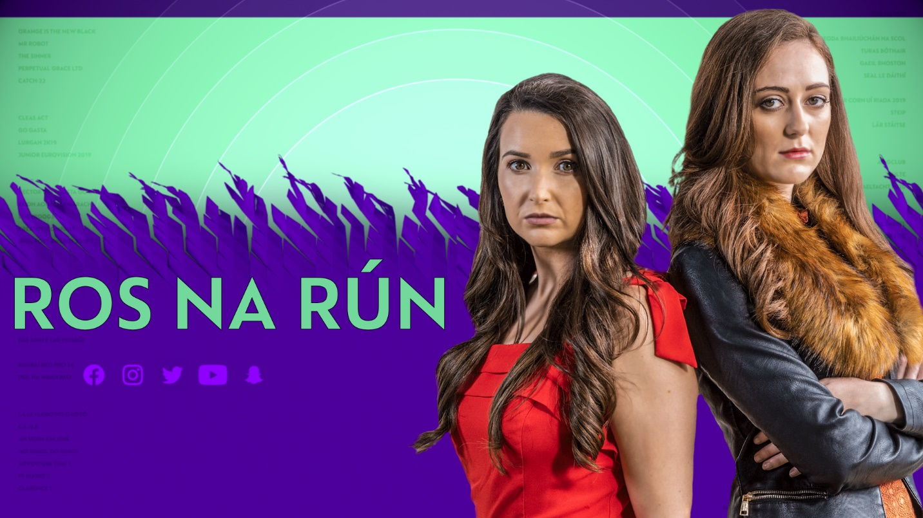

Is é Ros na Rún an tsraith is faide ar TG4, sraith a bhfuil an-tóir uirthi. Is é an t-aon sobalchlár ar theilifís na hÉireann atá lonnaithe faoin tír. Níl aon easpa charachtar spéisiúil sa gclár seo agus pléitear ceisteanna móra an tsaoil gan fuacht, gan faitíos - idir chúrsaí grá agus caidrimh, gnó agus teaghlaigh, comharsana a bheith in éadan a chéile agus mór-fhadhbanna pearsanta agus pobail gan trácht ar scríbhneoireacht agus aisteoireacht den scoth. Beidh an lucht féachana ag tnúth go mór lena bhfuil i ndán do dheirfiúracha Uí Dhálaigh agus do Mack. An mbeidh Katy in ann a chur ina luí ar a hathair, John Joe, nach bhfuil sí as a meabhair, agus gurb í a deirfiúr Dee atá ag oibriú an chloiginn uirthi le díoltas a fháil? Idir an dá linn, níl a fhios fós cé hé athair Jay. Beidh an lucht féachana ag faire go grinn go bhfeicfidh said mar a phléifidh Mack le cúrsaí agus ar na nithe a thitfidh amach sa tsraith seo. Tá muintir Uí Dhálaigh curtha soir siar agus tá a bhfuil ag tarlú i measc a chuid iníonacha ag goilleadh go mór ar John Joe.

TG4's longest-running and best-loved series. The flagship soap opera is the only one in the Irish language. Its engaging story lines bring the strong characters through awkward situations, extreme jeopardy with many laughs to be had along the way. From the kindling of romance to consequent broken hearts, for some but not all. In its unique natural style, Ros na Rún deals with the many social issues communities are faced with in today's world and excels in the exposure of such matters with insightful writing and acting. Viewers eagerly await the fate of the Daly sisters and Mack. Can Katy convince her distraught father, John Joe she’s not insane, that it’s her sister Dee who’s coercively controlling her for revenge. Meanwhile Jay’s paternity hangs in the balance. Viewers will eagerly watch for Mack’s reaction and moves this season. The Daly family are ultimately being torn apart, as a forlorn John Joe becomes more distraught at his daughters situation.
Arna léiriú ag Ros na Rún

Seal le Dáithí
Tá Dáithí Ó Sé ar ais don dara sraith de 'Seal le Dáithí' ar TG4. Beidh dreas comhrá aige gach seachtain le haoi éagsúil ina ndéanfaidh an té sin cur síos ar a shaol agus ar a shaothar. I measc na ndaoine a chaithfidh seal le Daithí beidh Príomhfheidhmeannach Trócaire, Príomhfheidhmeannach Institiúid Margaíochta na hÉireann, cumadóirí is scríbhneoirí, amhránaithe, pearsana spóirt, teagascóir ióga, dornálaí a bhfuil bonn Eorpach buaite aige atá anois ag díriú ar na Cluichí Oilimpeacha, oiliúnóir gairmiúil i scileanna sléibhe agus iar-Aire Stáit atá anois ina shagart.
Dáithí Ó Sé hosts series two of his weekly chat show 'Seal le Dáithí' on TG4. Each week Dáithí will chat one-to-one with a different guest where they will discuss and share their life story and experiences. Beginning on Thursday 3rd October, this 20 part series will include some of the following guests; CEO of Trócaire, CEO of the Marketing Institute of Ireland, composers, writers, singers, sports personalities, a Yoga instructor, a European boxing medallist and Olympic hopeful, an international mountain leader and a former Minister of State who has recently been ordained a priest.
Arna léirú ag / Produced by Nemeton

Beidh Aonach Amárach
Spraoi agus spórt, díospóireacht agus comhluadar - sin mar a bhíonn ag Taispeántais Feirme na tíre. Tabharfar léargas ar 'Beidh Aonach Amárach' ar roinnt den 140 taispeántas feirme a bhíonn ar siúl ar fud na tíre gach bliain. Caitheann na mílte míonna ag fáil faoi réir do na comórtais agus téann ó cheann ceann na tíre chucu. Sraith é 'Beidh Aonach Amárach' a thabharfaidh léargas ar na daoine a bhíonn á n-eagrú, na daoine a bhíonn i láthair agus ar ndóigh na daoine, de gach aois agus cúlra, a bhíonn san iomaíocht sna comórtais - ó bhearradh caorach go cniotáil.
Witness the excitement, tension and fun as we join the competitors going for glory at Ireland's country shows and fairs. With 140 agricultural shows across Ireland, this scene is hugely popular with competitors and spectators. Every year thousands of people spend months of preparation before travelling the country to take part in the competitions every weekend. We see competitors giving everything to be Best in Show -from cakes to cattle, flower-arranging to sheep-shearing, show-jumping to shiny cars, never mind the best vegetables, dogs, birds, clothes, art and craft.
Arna Léiriú ag / Produced by Crawford McCann

STEIP 2019
Príomhchomórtas damhsa ar an sean-nós na ndaoine fásta agus na ndaoine óga beo ó Oireachtas na Samhna 2019 in Óstán Citywest, BÁC
The principal sean-nós dancing competitions in the youth and adult categories live from Oireachtas na Samhna 2019 in the Citywest hotel, Co. Dublin
Arna Léiriú ag / Produced by Telegael

Lár Stáitse
Clár siamsaíochta beo atá dírithe ar rogha iomaitheoirí a bheidh páirteach sna comórtais ardáin do dhaoine óga ag Oireachtas na Samhna 2019 in Óstán Citywest, BÁC
Live entertainment show featuring competitors and winners from the under 18 competitions from Oireachtas na Samhna 2019 in the Citywest hotel, Co. Dublin
Arna léiriú ag / Produced by Telegael
Corn Uí Riada
Buaicphointí phríomhchomórtas amhránaíochta ar an sean-nós Oireachtas na Samhna 2019 ó Óstán an Citywest, Baile Átha Cliath.
Highlights from the principal sean-nós singing competition from Oireachtas na Samhna 2019 in the Citywest Hotel, Co. Dublin

Nuacht TG4

Caithfidh foireann fhuinniúil Nuacht TG4 súil eile ar nuacht an lae, seacht lá na seachtaine: scéalta sainiúla Gaeltachta agus Gaeilge, scéalta áitiúla agus réigiúnacha chomh maith leis an nuacht náisiúnta agus idirnáisiúnta is déanaí: sin atá i gcroílár Nuacht TG4.
To see the súil eile perspective of our news coverage, tune in to the dedicated and energetic Nuacht TG4 team at 7pm every night. At the heart of this TV news service with a difference is a distinctive non-centrist mix of news from a regional, local, Gaeltacht and Irish-language perspective, along with national and international stories.
Arna léiriú ar RTÉ do TG4

7 Lá
Sraith cúrsaí reatha beo as Baile na hAbhann gach Máirt @ 19:30 ar TG4
Pléifear na príomhscéalta polaitíochta agus na mórscéalta náisiúnta agus idirnáisiúnta gach seachtain.
TG4’s current affairs series live from Baile na hAbhann every Tuesday at 19:30
Each week we'll discuss the main political issues as well as major national and international stories. A special emphasis will be placed on regional stories from the Gaeltacht and Irish language issues.
Arna léiriú ag RTÉ do TG4
CEOL/MUSIC

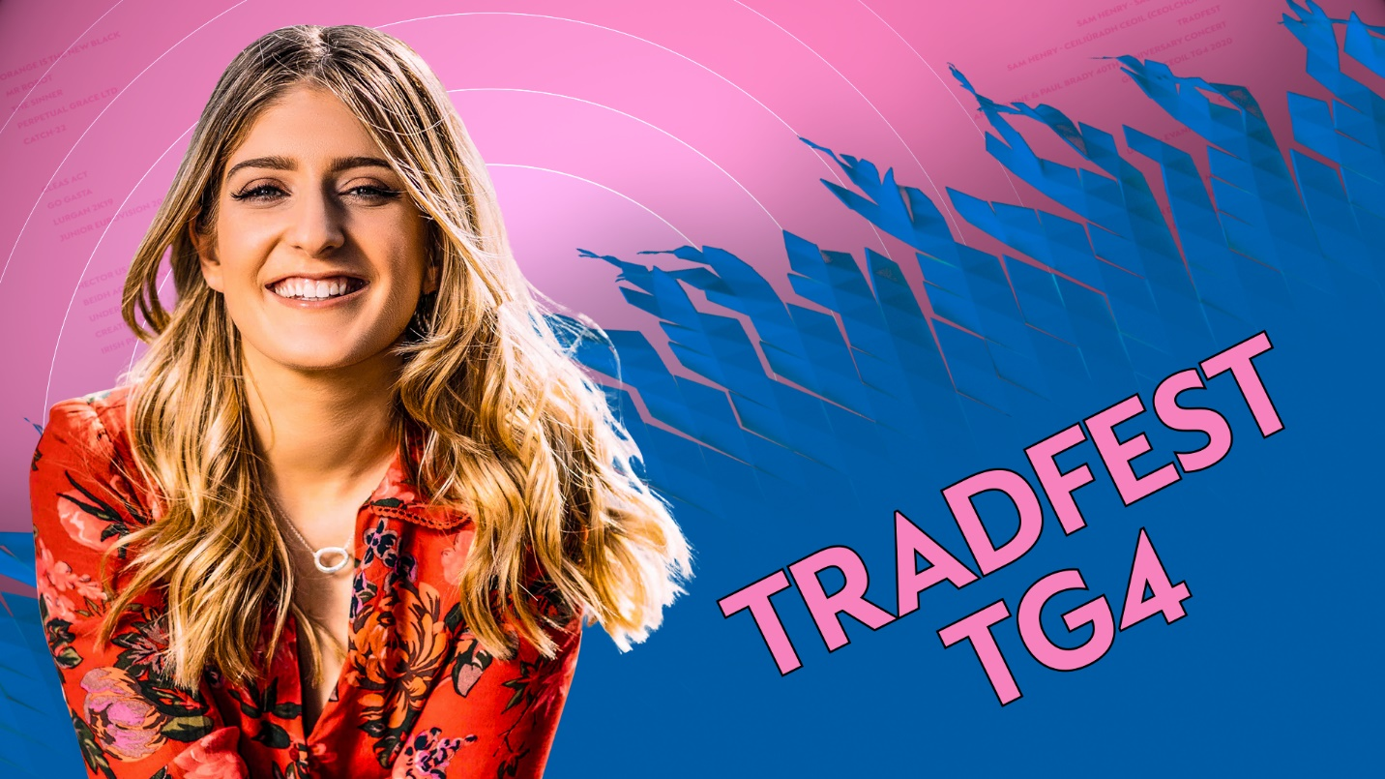

Tradfest TG4

Sraith ceoil thraidisiúnta & chomhaimseartha a taifeadadh beo ag TradFest i gcroílár na hard-chathrach. Á cur i láthair ag Doireann Ní Ghlacáin as Baile Átha Cliath, beidh ceol sa tsraith ó cheoltóirí as Éirinn agus thar lear chomh maith le daoine óga nua atá ag teacht chun cinn. I measc na gceoltóirí agus na n-amhránaithe beidh Mike McGoldrick, The Henry Girls, The Green Fields of America, Teddy Thompson, Inni K, Liam O'Connor agus go leor eile.
Tradfest TG4 returns for a second series from the heart of Dublin City, highlighting the very best of Irish traditional & contemporary folk music. Brought to you from The Printworks in Dublin Castle, The Chapel Royal, Liberty Hall & The House of Lords. Presented by Dubliner Doireann Ní Ghlacáin, Tradfest TG4 brings us music & song from Irish and International artists along with new up-and-coming talent. From The Henry Girls to Teddy Thompson, Liam O'Connor to Inni K and Mike McGoldrick to The Green Fields of America, Tradfest has something for everyone.
Arna léiriú ag Aniar TV / Produced by Aniar TV.

‘Sé Mo Laoch

Scéalta agus ceol mhórlaochra an cheoil agus na hamhránaíochta traidisiúnta in Éirinn. Sraith í seo a dhéanfaidh ceiliúradh ar shaol agus ar shaothar roinnt de na ceoltóirí agus na hamhránaithe is fearr aithne sa tír agus léireofar an éagsúlacht mhór atá idir na stíleanna ceoil agus idir na ceoltóirí traidisiúnta in Éirinn. I measc na n-aíonna, beidh an giotáraí Steve Cooney, an t-amhránaí Oiriall & an cumadóir Pádraigín Ní Uallacháin, fear na feadóige móire Patsy Hanly, an boscadóir den scoth Máirtín O'Connor. Is é an fidléir agus craoltóir Paddy Glackin a chuirfidh tús leis an tsraith.
'Sé mo Laoch TG4 tells the story of some of our greatest traditional musicians and singers. The series celebrates the musicianship and creativity of some of our most well known and respected performers & tells their stories in their own words. The series showcases the huge diversity of Irish traditional music and musicians, from Australian born guitarist Steve Cooney to Oriel traditional singer and composer Pádraigín Ní Uallacháin, from Roscommon flute player Patsy Hanly to Co. Galway accordion maestro Mairtín O'Connor and kicks off with Dublin fiddler & broadcaster Paddy Glackin.
Arna léiriú ag / Produced by Aniar TV

Gradam Ceoil TG4
Gradam Ceoil TG4 2020 as Halla an Waterfront i mBéal Feirste. Tiocfaidh plúr na gceoltóirí traidisiúnta ó gach cearn den domhan le chéile don ócáid speisialta seo.
Gradam Ceoil returns for 2020, bringing together the finest traditional musicians from far and wide for one spectacular celebration. From the Waterfront Hall, Belfast, Dónal O'Connor and Doireann Ní Ghlacáin preside over TG4's flagship traditional music awards.
Arna léiriú ag / Produced by Red Shoe Productions

The Sam Henry Collection

NUA - Sraith faisnéise dhá chuid ina bhfiosraítear scéal ar leith Sam Henry agus a bhailiúchán ceoil - Songs of the People - bailiúchán a bhfuil tábhacht ar leith ag baint leis go fóill do lucht ceoil ar fud an domhain, céad bliain i ndiaidh do Henry é a chur le chéile. Scannán faisnéise atá sa chéad chlár ina n-amharcfar ar an fhear taobh thiar den cheol agus an dóigh ar cuireadh bailiúchán ilchineálach a bhfuil breis agus 800 amhrán ann ar fáil mar gheall ar an dúil mhór a bhí ag Henry in iarsmaí an ama atá caite a chaomhnú.
NEW - Sam Henry - Saol 's Saothar -in a two-part series - comprised of a documentary and concert - looking at the man behind the music and how his passion for preserving the past produced a diverse collection of over 800 songs that is unique to Ulster and recognised internationally as one of the most important in the English language. Sam Henry began collecting songs and taking photographs while working as a customs and pensions officer.
Arna Léiriú ag / Produced by Below the Radar

Andy Irvine & Paul Brady 40th Anniversary Concert

Ceolchoirm, a taifeadadh i mí Bealtaine 2017, le ceiliúradh a dhéanamh ar Andy Irvine agus Paul Brady a bheith dhá scór bliain i mbun ceoil.
Andy Irvine and Paul Brady 40th Anniversary concert recorded in May 2017.

Opry le Daniel

Fillfidh Daniel O'Donnell ar Fhóram na Mílaoise i nDoire le 'Opry le Daniel'. Is iad na seó-bhannaí a bheidh faoi chaibidil sa tsraith seo - Nashville Country, Country Heroes, Country Gospel agus neart eile. I measc a chuid aíonna beidh Louise Morrisey, Frank McCaffrey, Paddy O'Brien & Mary Duff, Claudia & Jimmy Buckley, Dickie Rock, Red Hurley, Paddy Cole, Roly Daniels, Chloe Agnew, Cliona Hagan, Michael English, Patrick Feeney, Ashley Campbell, I Draw Slow, Max T. Barnes agus Catherine McGrath.
In this series Daniel O'Donnell returns to the Millennium Forum in Derry to present 'Opry le Daniel'. This series will feature Showbands, Nashville Country, Country Heroes, Country Gospel and more. Performing will be Louise Morrisey, Frank McCaffrey, Paddy O'Brien & Mary Duff, Claudia & Jimmy Buckley, Dickie Rock, Red Hurley, Paddy Cole, Roly Daniels, Chloe Agnew, Cliona Hagan, Michael English, Patrick Feeney, Ashley Campbell, I Draw Slow, Max T. Barnes and Catherine McGrath. Plenty of music and interviews.
Arna léiriú ag / Produced by Big Mountain Productions

Glór Tíre
Comórtas Ceoil Tíre – é Glór Tíre á chur i láthair ag Aoife Ní Thuairisg agus ag Séamus Ó Scanláin. Seisear iomaitheoirí a bheidh san iomaíocht arís i mbliana agus gach duine acu ag iarraidh an duais mhór a thabhairt leo. John Creedon, Caitríona Ní Shúilleabháin agus Jó Ní Chéide na moltóirí. Is iad Ciarán Rosney, Jim Devine, Trudi Lalor, Mike Denver, John McNicholl agus Patrick Feeney a bheidh mar mheantóirí i mbliana.

The country music talent show 'Glór Tíre returns to the Quays in Galway as the hunt for Ireland's best country talent continues. With help from Ireland's biggest country music stars six contestants battle it out. Presented by Aoife Ní Thuairisg and Seamús Ó Scanláin, with help from the judges John Creedon, Caitríona Ní Shúilleabháin and Jó Ní Chéide who ably guide the contestants. This years mentors are Ciarán Rosney, Jim Devine, Trudi Lalor, Mike Denver, John McNicholl and Patrick Feeney.

Arna léiriú ag / Produced by Gaelmedia
Drámaíocht/Drama

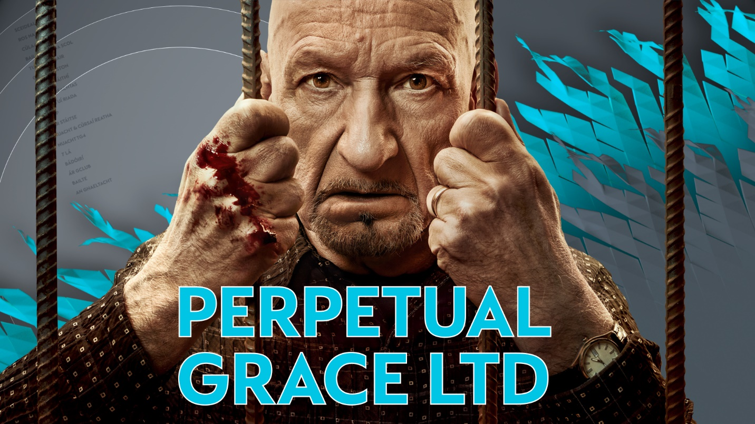

Perpetual GraceLTD

NUA - Sraith scéinséir as Meiriceá é Perpetual Grace LTD. Féachann fear óg an dallamullóg a chur ar an Tréadaí Byron Brown ach ní fada go dtuigeann sé gur contúirt cheart é an fear céanna. Níl bonn bán fágtha ag an Tréadaí ná ag a bhean Lillian ag na céadta duine sa bparóiste.
NEW - Perpetual Grace LTD follows James, a young grifter, as he attempts to prey upon Pastor Byron Brown (Ben Kingsley), who turns out to be far more dangerous than he suspects. The pastor and his wife Lillian - known to their parishioners as Pa and Ma - have used religion to bilk hundreds of innocent people out of their life savings.

Catch-22
NUA –Sraith nua le George Clooney, bunaithe ar úrscéal Joseph Heller den ainm céanna scéal é Catch 22 faoi Yossraian (Christopher Abbott), oifigeach in Aer Chór Mheiriceá le linn an Dara Cogadh Domhanda atá le ceangal go bhfuil na mílte duine nach bhfaca sé riamh ag iarraidh é a mharú! Ach ní hé an namhaid is measa dó ach a arm féin a bhíonn seasta ag cur le líon na misean a chaithfidh na fir a thabhairt i gcrích sular féidir leo éirí as. Ach má shíleann Yossarian imeacht óna chuid dualgas beidh sé ag sárú riail ar a dtugtar Catch-22 - riail áiféiseach a bhfuil na fir idir an bád agus an balla ceart aige.
NEW – Starring George Clooney, based on Joseph Heller's seminal novel of the same name, Catch-22 is the story of the incomparable, artful dodger, Yossarian (Christopher Abbott), a US Air Force bombardier in World War II who is furious because thousands of people he has never met are trying to kill him. But his real problem is not the enemy, but rather his own army which keeps increasing the number of missions the men must fly to complete their service. Yet if Yossarian makes any attempt to avoid his military assignments, he'll be in violation of Catch-22, a hilariously sinister bureaucratic rule which specifies that a concern for one's own safety in the face of dangers which are real and immediate is the process of a rational mind; a man is considered insane if he willingly continues to fly dangerouscombat missions, but a request to be removed from duty is evidence of sanity and therefore makes him ineligible to be relieved from duty.

The Sinner
An dara sraith de "The Sinner". Caithfidh an Bleachtaire Harry Ambrose dúnmharú lánúine a tharla ina bhaile dúchais féin i Nua-Eabhrac a fhiosrú. Nuair a thagtar ar na coirp, is cosúil gurb é mac na lánúine a dhúnmharaigh iad, gan chúis gan chiall. Dá mhéid a fhaightear amach faoin mbuachaill óg aisteach seo is ea is mó a fhoghlaimíonn Ambrose faoin méid atá á cheilt ag muintir an bhaile. Ní fada go mbíonn air aghaidh a thabhairt orthu sin atá ag iarraidh rúin a choinneáil faoi cheilt, Vera ina measc.
"The Sinner" returns for Season 2 with Detective Harry Ambrose called back to his hometown in rural New York to investigate a disturbing double homicide: parents murdered by their 11-year-old son with no apparent motive. Revelations about this strange boy and his unconventional background thrust Ambrose on a journey into the dark recesses of his hometown, where he comes up against those fighting to protect its secrets, including the mysterious Vera.

Orange Is the New Black
Tosaíonn sraith 4 leis na príosúnaigh ag baint gach sult as an loch in aice an phríosúin ó d'éalaigh siad! Ach is gearr é mar ní fada go ngabhtar arís iad agus ar fhilleadh ar an bpríosún dóibh bíonn príosúnaigh nua rompu, rud a chruthaíonn deacrachtaí ann féin. Tá a cuid trioblóidí féin ag Piper agus is cosúil go bhfuil gnó nua ag mná na nDoiminiceach i gcomórtas léise. I ngan fhios di féin freisin, is cosúil go bhfuil sí i gceannas ar ghrúpa nua de mhná geala! Tá Healy ag cur spéise i Lolly mar is cosúil mar go gcuireann sí a mháthair i gcuimhne dó.
Season 4 picks up where Season 3 left off: the inmates splashing about in the nearby lake after the mass escape; and Alex facing a menacing prison guard in the greenhouse. There's also another matter, which-once everyone's rounded up-causes headaches for everyone: a flood of new inmates. Piper also finds herself facing difficulties with the Dominicans who, after she rebuffs them, launch their own panty business; and she also inadvertantly forms and becomes de facto leader of a white-power group. Healy, meanwhile, takes a special interest in Lolly, who reminds him of his mother.

Mr Robot - Series 4
Sraith, a bhfuil Gradam Golden Globe buaite aici don 'Dráma Teilifíse is Fearr', faoi Elliot Anderson (Rami Malek a bhfuil Gradam Oscar buaite aige) innealtóir cibear-shlándála óg a bhíonn ag obair le grúpa rúnda haiceála, society.
Winner of the Golden Globe® for Best Television Drama, "Mr. Robot" follows Elliot Alderson (Oscar-winner Rami Malek), a young cyber-security engineer who becomes involved in the underground hacker group society, after being recruited by their mysterious leader.

Cine4

Is mórscéim nua é Cine4 do shaothair nua fadscannáin as Gaeilge. Is iad TG4, Fís Éireann agus Údarás Craolacháin na hÉireann a chuirfidh an maoiniú ar fáil don scéim seo faoin mbratach Cine4.

Spreagann Cine4, scéalaíocht láidir, samhlaíocht fhísiúil agus luachanna arda léiriúcháin sna mórscannáin a thagann as.

Cine4 is a new initiative, from a TG4, Screen Ireland and BAI partnership, to develop original feature films in the Irish language

Cine4 encourages strong storytelling, visual flair and high production values appropriate for the big screen.

Finky
Ceoltóir agus puipéadóir é Micí Finky atá ag súil éalú ón saol mar a bhí. Goideann sé clúdach airgid agus tugann sé féin agus cara leis, ó bhí sé ina ghasúr, aghaidh ar Albain. Ach baineann drochthimpiste do Finky an chéad oíche acu i nGlaschú agus fágann gan mothú é óna bhásta síos. Téann an saol in aimhréidh air ach údar misnigh dó obair a fháil le Carnival Chaotica, siorcas avant-garde, foiréigneach. Ní fada go dtuigeann Finky go bhfuil sé istigh le buíon ar leith agus go bhfuil sé ar thuras aisteach, millteanach agus nach bhfuil de rogha aige anois ach dul i ngleic leis an méid a bhain dó san am a caitheadh.
Micí Finky, a musician and puppeteer looking to escape his past, steals an envelope full of cash and runs off to Scotland with his childhood friend Tom Tom to start a new life. On their first night in Glasgow, Finky suffers a horrible accident and is left paralysed from the waist down. He hits rock bottom but is given a chance at redemption when recruited by Carnival Chaotica, a violent avant-garde circus. Finky embarks on a twisted odyssey that brings him over the rainbow but, as his journey becomes increasingly hellish and surreal, Finky realises that he must confront his tormented past.
Arna léiriú ag / Produced by Abú Media

Arracht
Fear é Coleman Sharkey atá fréamhaithe ina phobal. Fear leighis é a bhfuil scil aige i luibheanna mar a bhí ag a athair roimhe. San 19ú haois, tá ráflaí go tréan go bhfuil dúchan ar na fataí. In éineacht leis sin, tá an tiarna talún ar tí an cíos a dhúbailt ach nuair a théann Coleman chun cainte leis faoi, bíonn drochdheireadh ag an scéal. Fágann sin Coleman ina chónaí ar oileán san uaigneas agus suim caillte aige sa saol nó go gcastar Cití air, cailín beag deich mbliana, a mhúsclaíonn a spéis sa saol arís.
Coleman Sharkey, a man with deep roots in the community who heals people with herbs as his father did before him. In the 19th century there are rumors that blight has spoiled the potatoes. When the English Landlord doubles the rent before returning to England on a permanent basis, Coleman and Patsy try to reason with him. The night ends in fatal circumstances which leads to Coleman's dreary life on an isolated island, until he meets 10 year old Cití. Cití teaches him to be the person he once was and gives him reason to live.
Arna léiriú ag/Produced by Macalla Teo

Scannáin / Movies
Scannán na Seachtaine - 9.30pm Dé Luain/Mondays
Is iondúil gurb í an oíche Dé Luain an oíche is suaimhní den tseachtain agus beidh rogha tarraingteach scannán aitheanta ar fáil ar TG4, saor go haer, a choinneoidh comhluadar leat, a mheallfaidh agus a spreagfaidh tú.
Ar na scannáin a chraolfar an séasúr seo beidh Steve Jobs, Argo, The Stanford Prison Experiment, Frost/Nixon, Maudie, American Made, No Country for Old Men.
Monday night is stay at home night and we’ve lined up a mouth-watering selection of free to view movies that will entertain and engage.
Upcoming titles this season include Steve Jobs, Argo, The Stanford Prison Experiment, Frost/Nixon, Maudie, American Made, No Country For Old Men.

An Western - Dé hAoine/Friday Night Western
An réimse scannán is ansa le go leor de lucht féachana TG4 agus ar na scannáin aitheanta a chraolfar an séasúr seo beidh High Plains Drifter, 3:10 to Yuma, Two Mules for Sister Sara, A Fistful of Dynamite, For a Few Dollars More.
TG4 – home of the Western brings action from some of the much loved westerns such as Western: High Plains Drifter, 3:10 to Yuma, Two Mules for Sister Sara, A Fistful of Dynamite, For a Few Dollars More.

Movie an tSathairn/Saturday Night Movie
Ar na scannáin an séasúr seo, beidh: In her Shoes, About a Boy, This is Spinal Tap, As Good as it Gets, Julie & Julia, JFK, This is Spinal Tap.
The Saturday night movie on TG4 – expect entertainment from upcoming titles such as In her Shoes, About a Boy, This is Spinal Tap, As Good as it Gets, Julie & Julia, JFK, and many more.

Spórt / Sport
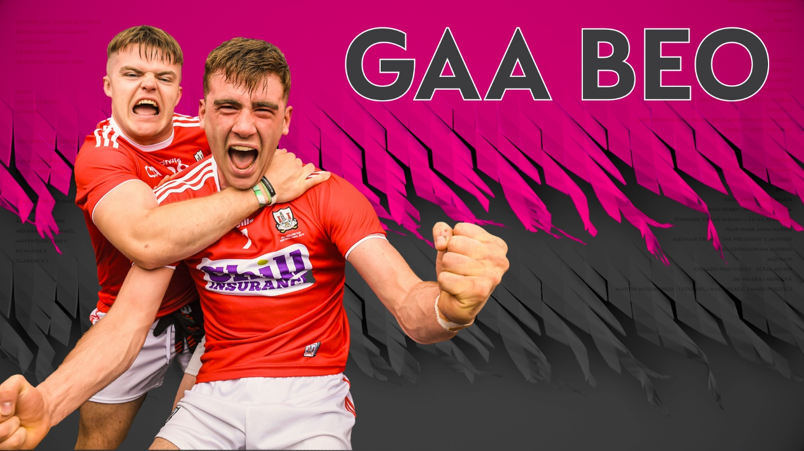
Peil na mBan Beo
Craolfar Cluichí Ceannais Pheil na mBan TG4 ar Pháirc an Chrócaigh beo ar Peil na mBan Beo Dé Domhnaigh an 15^{ú} Meán Fómhair.
Live coverage from the TG4 Ladies Football Finals from Croke Park.
Bhí an líon ba mhó daoine riamh i láthair anuraidh ag Cluiche Ceannais Peile TG4 idir Áth Cliath agus Corcaigh ar Pháirc an Chrócaigh. Ba é an líon ba mhó riamh é ag imeacht spóirt ban in 2019 - bhí 50,141 duine i láthair.
Tá an sé fhoireann a bheidh ag imirt Dé Domhnaigh an 15 Meán Fómhair ar eolas anois againn agus is gearr go mbeidh a fhios againn cé a thabharfaidh Corn na Sóisear, an Corn Idirmheánach agus Corn na Sinsear leo.
11:45am An Lú v Fear Manach, Cluiche Ceannais na sóisear
1:45pm An Mhí v Tiobraid Árann, Cluiche Ceannais Idirmheánach
4:00pm Áth Cliath v Gaillimh
Beidh Sraith LIDL, Craobh TG4 agus Cluiche Ceannais na gClub agus Réalta Peil na mBan chugainn chomh maith.

Rugbaí Beo Guinness PRO14
Beidh rogha tarraingteach cluichí ar TG4 ina mbeidh foirne na hÉireann san iomaíocht gach deireadh seachtaine feadh 22 deireadh seachtaine go dtí na babhtaí ceathrú ceannais.
Is í Máire Treasa Ní Dhubhghaill an láithreoir agus beidh tráchtaireacht againn ó Garry Mac Donncha agus anailís ó Marcus Horan, Ronan Loughney, Eoghan Ó Neachtain, Eimear Considine agus Éamonn Molloy.
Matches from each round of the Guinness PRO14 featuring the Irish provinces, presented by Máire Treasa Ní Dhubhghaill, commentary from Garry Mac Donncha and analysis from Marcus Horan, Ronan Loughney, Eoghan Ó Neachtain, Eimear Considine agus Éamonn Molloy.

GAA Beo
Craoladh beo eisiach teilifíse ar chluichí Gaelacha, Meán Fómhair- Bealtaine. Is ar Chluichí Ceannais Contae i Sraith Allianz agus ar Chraobh na gClubanna AIB sa pheil agus san iomáint a bheidh an bhéim idir Deireadh Fómhair agus Nollaig 2019 agus cluiche mór beo gach Domhnach agus Craobh Iomána Faoi 20 BGÉ, Craobh Peile Faoi 20 EirGrid, Craobhacha Iomána & Peile Mionúr Electric Ireland.
Live Coverage of GAA matches.

Rásaí Lios Tuathail
Beochraoladh ar 5 lá ó Fhéile Rásaíochta Capall Lios Tuathail, 9-13 Meán Fómhair. Is é an Guinness Kerry National Steeplechase Dé Céadaoin an 11 Meán Fómhair buaic na féile, rás ar fiú €160,000 é don bhuaiteoir. Dé hAoine an 13 Meán Fómhair, Lá na mBan.

Live coverage of 5 days of the Harvest Festival in Listowel, featuring the Kerry National

GAA 2019
Uair an chloig de bhuaicphointí ó chluichí móra an deireadh seachtaine.
Comprehensive coverage of both football and hurling leagues.

Dornálaíocht Beo
Beo ón Staid Náisiúnta i mBÁC – Craobhchomórtais Dornálaíochta na hÉireann
Boxing Live coverage of the finals of the National Elite Championships in November.

Réalta Peile na mBan 2019
Clúdach ar ócáid mhór shóisialta na bliana ag Peil na mBan, tráth a bhfógraítear foireann Réaltaí na Bliana i láthair aíonna speisialta, maithe agus mór-uaisle an Chumainn agus na himreoirí féin.
Highlights of the gala TG4 Ladies Football All-stars.

Laochra Gael
Séasúr eile de chuimhní cinn agus ómós do mhór-imreoirí peile agus iomána ón am atá caite. Tugann na himreoirí féin, a gcomhghleacaithe, a gcéilí comhraic agus tráchtairí aitheanta a mbreithiúnas féin orthu le cabhair ó mhíreanna ón gcartlann spóirt dá gcuid imeartha. Seo a leanas cuid de na laochra a bheidh á gceiliúradh: Alan Brogan (Áth Cliath), Diarmuid Lyng (Loch Garman), Iggy Clarke (Gaillimh), Brenda McAnespie (Muineachán), David Brady (Maigh Eo) agus Kieran Donaghy (Ciarraí).
Laochra Gael returns to TG4 for the 18th series next spring. Featuring 6 new "Laochra" each with their own unique personal story told both on and off the field. This series will include Kieran Donaghy - Ciarraí, Alan Brogan - Áth Cliath, Brenda McAnespie - Muineacháin, Iggy Clarke - Gaillimh, Diarmuid Lyng - Loch Garman, David Brady - Maigh Eo.

Tour de France 2020
Craoladh beo ar Tour de France 2020.
Tour de France – TG4’s acclaimed live coverage throughout the Tour de France

Leadóg – Tennis
Craoladh beo ar chomórtais na bhfear agus na mban i gCraobhchomórtas Oscailte na hÉireann AIG sa Leadóg.
Live coverage of the finals of the AIG Irish Open

Lúthchleasaíocht Beo
Craoladh beo ar Thionól Lúthchleasaíochta Idirnáisiúnta na bliana seo de chuid Spórt Chathair Chorcaí.
Featuring live coverage from top athletics meetings held in Ireland such as the AIT Grand Prix and the Cork City Sports.

Cispheil – Basketball
Craoladh beo ar Chluiche Cheannais Chorn Hula Hoops as an Láthair Náisiúnta Chispheile i mBaile Átha Cliath.
Live coverage of the Hula Hoops National Cup Finals

On the Limit Sports (Motorsport Ireland):
Clár seachtainiúil buaicphointí do lucht leanta railí sa tír seo.
Highlights of all the action from the world of Rally in Ireland.
Daoine Óga/ Young Peoples
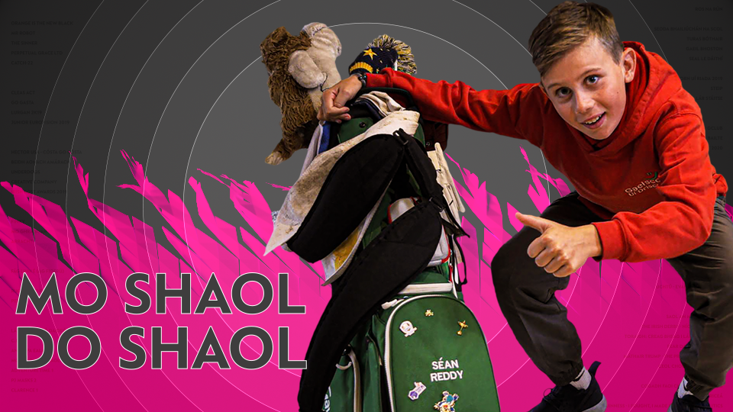

Lá le Mamó Lá le Daideo
NUA - Sraith clár ina gcaithfidh páistí óga idir 5 go 8 mbliana an lá in éineacht le Mamó nó Daideo chun scil nua a fhoghlaim nó chun tabhairt faoi ghníomhaíocht a mbaineann siad beirt sult as. Bí i dteannta na bpáistí agus a seantuismitheoirí ó cheann ceann na tíre - ó thrí oileán Árann go Rinn ó gCuanach ó dheas chomh maith le Ráth Chairn Glas na Mí.

NEW - Series in which children between 5 and 8 spend a day with one of their grandparents learning a new skill or taking in part in a hobby they both enjoy. The episodes are based in various regions all over the country, including the Aran Islands, Ring in Waterford to Rathcarran in Co. Meath.
Arna léiriú ag / Produced by Meangadh Fíbín.

An Siopa Ealaíne
NUA - Is sraith ealaíne nuálach é Siopa Ealaíne atá dírithe ar ghasúir réamhscoile. Múinfidh an láithreoir Neasa scileanna ealaíne ar bhealach siamsúil agus spraíúil as a siopa féin i gcroílár an phobail i mbaile beag álainn cois farraige. Tagann a cairde ar cuairt gach lá agus iad ag lorg comhairle ealaíne uirthi. Beidh neart spraoi, spórt agus ealaíon i siopa Neasa. Fáilte isteach!
New - Siopa Ealaíne is an innovative series aimed at pre-school children in which Neasa will teach us how to be creative in a fun and playful way. Neasa is an artist who has her own little shop in the heart of a beautiful seaside town. Her friends visit her everyday for creative tips and we will get to know them all while Neasa helps them out with her art classes. It's all fun and games while at Neasa's. Come on in and get creative!
Arna léiriú ag / Produced by Meangadh Fíbín

Is Mise
Sraith uaillmhianach í seo ina mbeidh ceathrar láithreoirí óga a bheidh ag fiosrú agus ag foghlaim faoin domhan ar a mbealach ar leith féin. Beidh muid i dteannta Ríona, Róisín, Joey agus Cóil ar eachtraí éagsúla agus iad ag foghlaim agus ag tabhairt faoi réimse leathan gníomhaíochtaí i ngach clár, ó chuairt ar mheitheal briogáide dóiteáin go cóiriú bláthanna, ón bhfeirmeoireacht go ceacht hip hap. Cuirtear ábhar nua i láthair i ngach clár, ábhar agus gníomhaíocht a mbeidh suim ag a gcomhaoisigh ann.
This ambitious series follows four young presenters, as they discover the world from their own perspective. We follow Ríona, Róisín, Joey and Cóil on various adventures as they learn and explore with activities ranging from the fire brigade to flower making, from sailing to learning how to swim. Each episode introduces a new experience relating to what children within this age group are interested in.
Arna léiriú ag / Produced by Meangadh Fíbín

Ár Scéal

Tabharfaidh Úna Ní Fhlatharta cuairt ar 52 bunscoile ar fud na tíre chun scéalta a bhailiú agus chun cabhrú leis na daltaí óga tabhairt faoi thograí móra ealaíne bunaithe ar charachtair agus ar théamaí na scéalta sin. Glacfaidh Úna agus na páistí inspioráid ó na scéalta ar leith agus beidh an-spraoi acu ag cruthú ealaíne bunaithe ar na gnéithe éagsúla a bhaineann leo. Éistfidh Úna agus na páistí leis an scéal féin ar deireadh agus cuirfidh an ealaíon nuachruthaithe i láthair.
This ambitious series follows presenter, Úna Ní Fhlatharta, in her funky art-filled van, as she visits 52 primary schools nationwide to collect delightful stories, lovingly illustrated by the children themselves. Each episode sees Úna and the children draw inspiration from their unique story to create imaginative and innovative artwork that will allow the story to come alive. Both Úna and the children enjoy creating and making before they eventually listen to the story being told in full by one of the schoolchildren.

Arna léiriú / Produced by Meangadh Fíbín

C.L.U.B

Gach seachtain, díreoidh C.L.U.B ar chlubanna éagsúla Chumann Lúthchleas Gael. Leagfar an-bhéim ar spiorad foirne agus beidh na láithreoirí Diarmuid Lyng agus Máire Ní Bhraonáin ag iarraidh na clubanna is mó spraoi agus craic a aimsiú. Beidh neart spraoi, ceoil, scileanna agus dúshlán sa stiúideo. Beidh neart aíonna aclaí sa stiúideo chomh maith agus beidh neart nod agus comhairle le fáil ón tráchtaire mór le rá, Mícheál Ó Muircheartaigh.

An exciting and fun show about GAA Clubs all over the country and the craic that everyone has playing with them. C.L.U.B is presented by Cárthach Bán Breathnach. Each week he travels to a different GAA club around the county to meet the young players from the club. We are going all over the country from Gaoth Dobhair to Cork and Dublin to Conamara. On every show we'll see young players out on the pitch and in the studio chatting, practicing new skills, playing games in the studio... AND at the end of every episode one lucky player will get the opportunity to dump the toughest coach from the club into the DUNK TANK!! Finally revenge for all those extra laps at training!!!

Arna léiriú ag / Produced by Macalla Teo

Mo Shaol do Shaol
NUA - Sraith ina mbabhtálfaidh beirt, nach bhfuil cosúlacht ar bith acu lena chéile, an saol mar a chaitheann siad é ar feadh aon lá amháin. Beidh dúshlán mór le tabhairt i gcrích freisin acu faoi dheireadh an lae. Beidh beirt nua i ngach eagrán agus díreofar sna dúshláin ar réimse leathan caitheamh aimsire atá ag daoine óga in Éirinn sa lá atá inniu ann - beidh gach cineál againn ó júdó, go haca oighir, cruicéad & neart eile. D'fhéadfadh nach mbeadh spéis dá laghad (ná aon eolas!) ag na rannpháirtithe ar chaitheamh aimsire a chéile ach ní bheidh aon rogha acu ach bualadh faoi agus foghlaim go sciobtha - beidh torthaí spleodracha i gceist leis.
NEW - A series where we take two people who are totally different from one another & make them swap hobbies and lives for a day....AND they have to complete an incredibly difficult challenge before the day is out. We have two new contestants in every episode and we focus on the wide range of pastimes & hobbies young people in Ireland have today. We have it all - Judo, Ice-Hockey, Cricket & much much more. There is a good chance our contestants will have no interest (or knowledge) in their new hobby but they'll have to learn quickly! The results will be electrifying.
Arna léiriú ag / Produced by Macalla Teo

